**Analysis of Child Care Services in the Neighborhoods of Edmonton, AB**

AbdAllah Elsheikh

February 23rd, 2020

1. **Introduction**

Planning Child care services in a city is very crucial to ensuring sustainable services for families in different communities. It is also essential to support the children development by ensuring that the child care services are accessible, less crowded, and properly managed.

In this exploratory exercise, I will explore and analyze different neighborhoods in the city of Edmonton, AB, to identify which areas are possibly underserved when it comes to child care.

This can be a great insight for anyone who is interested in starting a child care business in the city.

It would be able to quickly visualize neighborhoods with a higher children population in different categories, mainly (0 to 4 years) which is a potential successful area to start their business.

The analysis can also help city officials to identify neighborhoods where more investment in child care services is needed.

1. **Data acquisition and cleaning (Data sources, Data preparation)**
   1. Data Sources:

I have initially relied on two main datasets from the city of Edmonton, in addition to venues data from Foursquare as suggested by the instructor. Unfortunately, foursquare have very little venues data for Edmonton, AB, and it actually had no data for “Daycare” venues in the city. For that reason, I have used a third dataset provided by the government of Alberta for daycares in Edmonton but the dataset is not complete. The details of the datasets are as follows:

***Dataset 1: Edmonton City Neighborhoods boundaries data – City of Edmonton***, which contains the following columns: Neighborhood, Longitude, and Latitude. To access the dataset, [click here](https://data.edmonton.ca/Administrative/Neighbourhood-Boundaries-Tableau-/jyhf-jwft).

***Dataset 2: Edmonton Population data – City of Edmonton***, which contains the following columns: Neighborhood, Population (Age 0-4), Population (Age 5-9), Population (Age 10-14). To access the dataset, [click here](https://data.edmonton.ca/Census/2016-Census-Population-by-Age-Range-Neighbourhood-/phd4-y42v).

***Dataset 3: Child Care Information Dataset - Government of Alberta***, which contains the following columns: Type of Program, Program Address, Program City, Postal Code, Neighborhood, Phone Number, Capacity, Accreditation Status. To access the dataset, [click here](https://open.alberta.ca/opendata/childcareinformation#summary).

* 1. Data Preparation:

After downloading the first dataset, Edmonton City Neighborhoods Boundaries, I needed to remove any unnecessary columns such as Wards, or IDs, and then calculate the mean value of the boundaries longitude/latitude to get a center point of latitude/longitude for each neighborhood in Edmonton city.

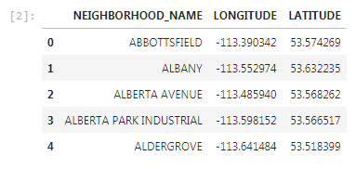

For the second dataset, Edmonton population data, I removed the columns that are not needed including age groups that are not from 0 to 14, to keep the focus on the younger population.

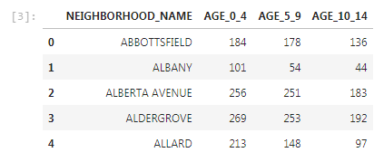

For the thirds dataset, Alberta child services information, other cities in the province were filtered out and all columns that are not used in the analysis were also removed.

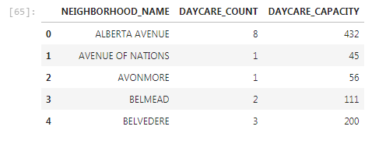

1. **Methodology - Exploratory Data Analysis**

The first step in this analysis was to explore the children population in each neighborhood in the city of Edmonton, with the focus on the age group 0 to 4 years old. This group most likely needs the daycare services in the area.

Dataset 1 and Dataset 2, Edmonton Neighborhoods spatial data and Edmonton Population data were merged, then plotted to represent the population of children, ages 0 to 4 years old in each neighborhood. A sample of the merged dataset looks like the following:

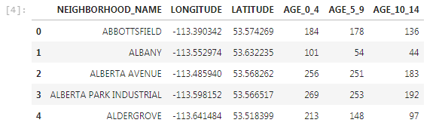

The plotted map with the children population is as follows:

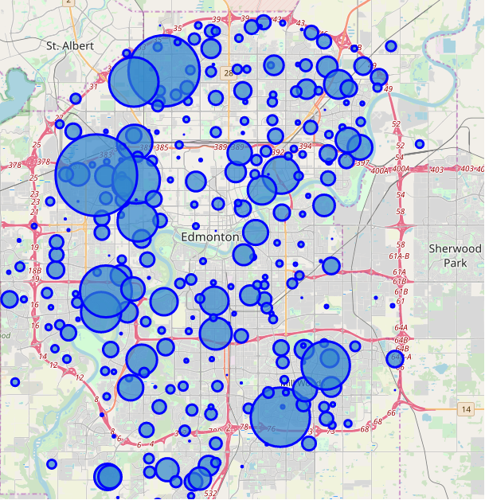

To be able to compare the map above to the daycares data, I initially used foursquare data but I could find no “Daycare” venue category or any “Child Care Service” category. The only category that was returned by foursquare maps was “School” and that was not even populated. Please see the map below:

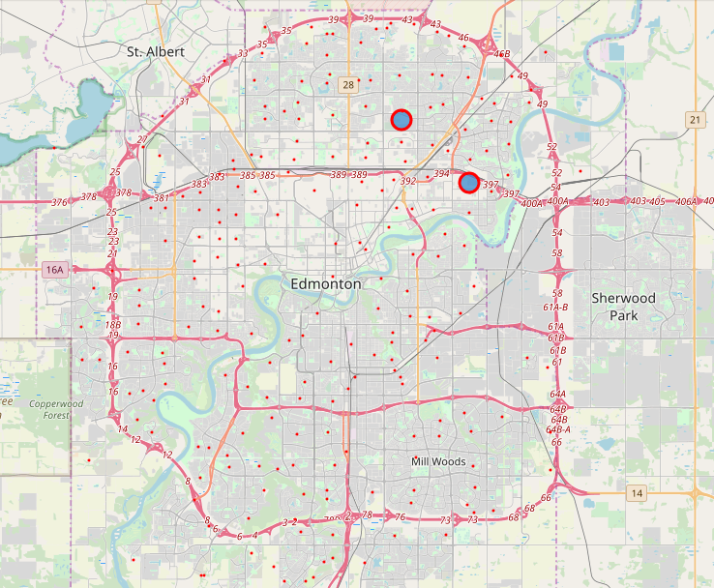

I would like to note that I have tested the code multiple times with other cities and the code works as expected. In addition, I have manually explored foursquare website and got the same results for the city of Edmonton, AB.

The map above is for the “School” venue category, which also retrieved only 2 locations for schools around the city. I believe foursquare does not have the data I needed for this analysis and this is why I resorted to other dataset provided by the government of Alberta.

To be able to proceed with the analysis, I used the third dataset, Child Care Services information, from the government of Alberta, converted the addresses to neighborhoods, and then presented the data in another map, where each marker represents the number and capacity of all daycares in each of the available neighborhoods. The daycares distribution map is as follows:

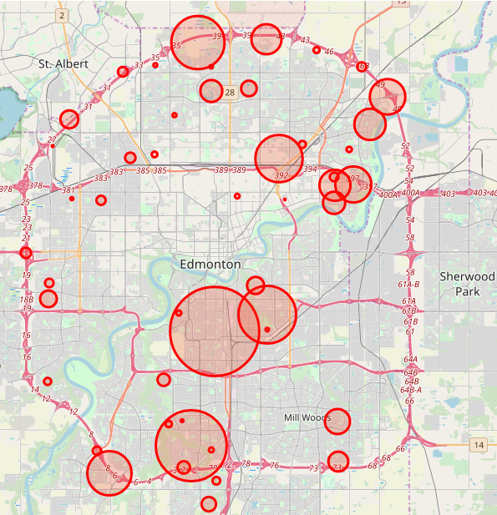

The markers on the maps are normalized to show visually proportionate circles that map to the number of children age 0 to 4 years old and to map to the capacity of the daycares in the neighborhood.

By comparing the two maps, we can identify neighborhoods with more children and less daycares capacity, which are potential candidate to start a child care business. We can also identify areas with fewer children population but higher concentration of child care services/businesses.

1. **Results & Discussion**



By visually comparing the two maps above, we can easily identify clusters of neighborhoods where there is a large children population, especially age 0 to 4, but does not have the capacity in the current daycare business. Such neighborhoods, mainly in the northwest, the southwest, and the southeast part of the city are good candidates to start a new daycare business.

That should also capture the attention of the city officials and guide them to neighborhoods that are either underserved or overserved.

Identifying neighborhoods with larger children population can serve as an input for planning future schools, playground areas, and other family oriented services.

1. **Conclusions**

In this study, I analyzed the child care services in the neighborhoods of the city of Edmonton, AB, in relation to the population of children, age 0 to 4 years old, in order to identify neighborhoods that are underserved or overserved, and to identify future child care business opportunities for investors.

I also tried to highlight the fact that a larger young population means a need for planning other services and family oriented facilities in the area to support healthy living and child development.

In terms of datasets, foursquare maps can improve their database on businesses in Edmonton, AB.